Step-by-Step: Installing ASI

| August-20 |

**Document Overview**

**Documentation Goals**

This documentation is intended to provide step by step instructions for ***Installing ASI, and updating the ASI Help Database****.*

**Table of Contents**

**Installing on Windows XP/NT/2000** 2

New Client Computer or Existing Network Computer 2

**Update ASI Help Database** 3

Step One: Download Advanced Software Help Files 3

Step Two: Run Progress Folder Utility 3

Step Three: DOS Prompt 4

Step Four: Run Utility 4

# **Installing on Windows XP/NT/2000**

## New Client Computer or Existing Network Computer

1. Install Progress CD’s to the local computer.
2. Create a new folder on the new computer called:
   * C:\TMP
3. Copy the following folder:
   * From Existing Computer Location: C:\Program Files\Progress
   * To New Computer Location: C:\Program Files\Progress
4. Copy the following folder:
   * From Network Drive File: F:\asigui\misc\ADM2
   * To New Computer: C:\Program Files\Progress\GUI
5. Copy three lines from the document at the following location:
   * From Network Drive: F:\asigui\misc\services\
   * On New Computer: Open file C:\windows\system32\drivers\etc\services  
     Paste the three lines to the end of the file plus one blank line at the end then *Save*.
6. Copy XPRINT software to client.
   * From new client computer via Explorer: Access Network Drive F:\asigui\misc\Xprint\Xprint6.1.exe file and double click.
   * This will begin the installation of XPRINT.
   * This will prompt to install the XPRINT software.
   * Select the C:\program files\progress\bin\
   * When prompted for the destination directory, accept the default location.
7. To install *Icon*
   * Copy *Icon* from the existing work computer.

# **Update ASI Help Database**

## Step One: Download Advanced Software Help Files

First, the Advanced Software Help files must be downloaded to the Advantzware Database folder. The files are titled as follows:

|  |
| --- |
| ASIHELP.DB |
| ASIHELP.B1 |
| ASIHELP.D1 |

## Step Two: Run Progress Folder Utility

The user must run a utility from the existing *Progress* folder. The best way to access the proper directory is as follows:

* Click the ***“Start” / “Windows”*** button.
* Click ***“All Programs”***
* Click ***“Progress”***
* Click ***“PROENV”*** to find the *Progress* environment.

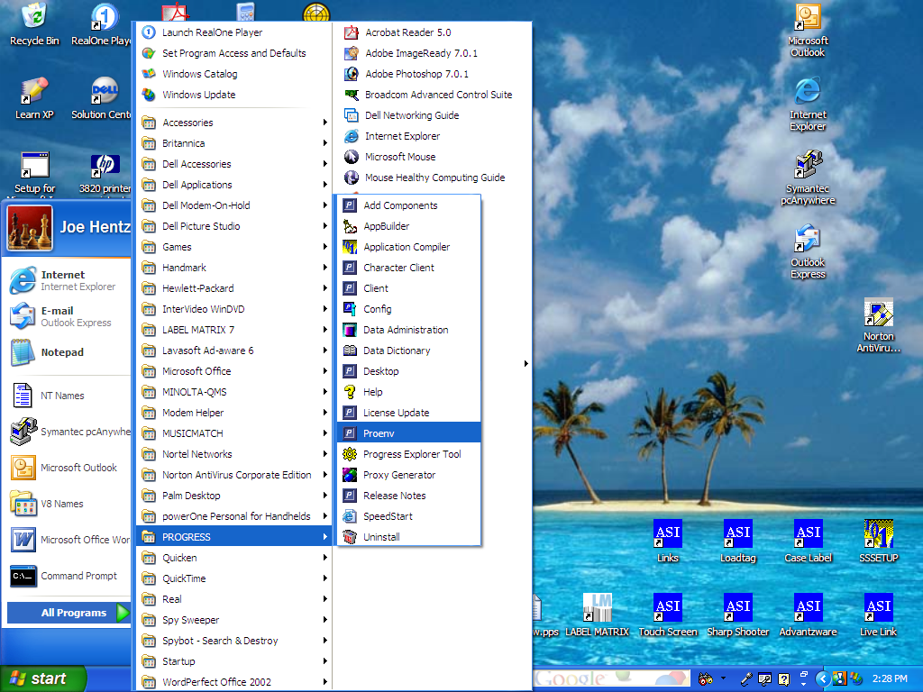

## Step Three: DOS Prompt

When the *DOS* prompt appears with the existing Progress folder, the DOS prompt should default to the following:

* Program Files/Progress/Bin folder to the WRK directory or current directory.

The user should then type the following:

* ProStrct Repair SI_GUI9\DB\ASIHELP

Please Note: The ASI_GUI9 may be named differently on your server, hence replace this command with your properly named folder.

## Step Four: Run Utility

Once done, run the following utility:

* ProStrct Repair SI_GUI9\DB\ASIHELP

Please Note: The ASI_GUI9 may be named differently on your server, hence replace this command with your properly named folder.

